Advanced Security Rules
Firebase Firestore — Beyond FlutterFlow UI
A Practical Developer Guide using Posts & Chat Use Cases

1. Introduction

FlutterFlow and Firebase — A Quick Recap
FlutterFlow is a visual low-code platform for building Flutter applications. It connects natively to Google Firebase, using Cloud Firestore as the primary database layer. FlutterFlow generates production Flutter/Dart code behind the scenes and deploys it alongside Firebase backend services — meaning your data security is ultimately governed by Firebase, not your app's UI.
Every read, write, create, and delete request your app makes goes through Firebase before it reaches any data. This is where Security Rules live — and where advanced rules become essential for real-world applications.

What are Firestore Advanced Security Rules?
Firestore Security Rules are server-side access control policies written in a declarative language specific to Firebase. They evaluate every incoming request against conditions you define, and either allow or deny the operation before it reaches your database.
The 'advanced' aspect refers to rules that go beyond the four simple dropdowns FlutterFlow provides in its UI. Advanced rules allow you to:

- Validate field values: Ensure required fields exist, are non-empty, or fall within acceptable ranges before a document is written.
- Write custom helper functions: Reusable logic blocks (like isSignedIn() or isOwner()) that keep rules readable and maintainable.
- Cross-collection lookups: Check data in a different Firestore collection as part of the rule evaluation — e.g., verify a user has an active subscription.
- Multi-participant access: Allow access based on array membership — e.g., any participant listed in a chat's participants array can read its messages.
- Role-based access control: Grant different permissions to admins, moderators, and regular users based on a role field stored in their user document.
- Conditional field protection: Allow updates only to specific fields, preventing users from overwriting critical fields like created_by or created_at.

🔑 Core Principle
Advanced rules run entirely on Firebase servers. They cannot be bypassed by modifying the app, intercepting network calls, or using the Firebase SDK directly from a browser console. No matter how a request reaches Firebase — through your app, a script, or a REST call — the rules evaluate it the same way.

2. Why Advanced Rules — The Critical Gap

The Illusion of Security: UI Filtering vs. Server Rules
This is one of the most misunderstood aspects of app development, and understanding it correctly is the single most important reason to implement advanced rules.

⚠️ Real Scenario: The Filtered Query Problem
Imagine you have a posts collection. In FlutterFlow, you build a query to show 'My Posts' — you add a filter: created_by == currentUser. The screen displays only your posts. Everything looks correct.

But here is what is actually happening behind the scenes:
1. FlutterFlow sends a Firestore query with a where clause to the database.
2. Firebase loads ALL documents that pass the Security Rule check — not the UI filter.
3. If your Read rule is set to 'Authenticated Users' (or worse, 'Everyone'), Firebase returns ALL posts to the app.
4. FlutterFlow then applies the created_by filter CLIENT-SIDE, hiding the other posts from the visible list.
5. The other posts are FULLY LOADED in memory and visible in the browser's developer console or a network inspector.

A malicious user only needs to open DevTools → Network tab → inspect the Firestore WebChannel response to see every post loaded — regardless of the UI filter.

Visualising the Problem

❌ Without Server Rules  App requests posts...  Firebase returns ALL 500 posts  App filters to show only yours  DevTools: all 500 posts visible!  Malicious user harvests all data | ✅ With Server Rules  App requests posts...  Firebase rule checks created_by == currentUser  Firebase returns ONLY your 3 posts  DevTools: only your 3 posts visible  Nothing to harvest — data never left the server

Where FlutterFlow UI Rules Fall Short
FlutterFlow's built-in rule editor covers the most common scenarios well. But there are several situations where it simply cannot express what you need:

FlutterFlow UI Limitation | Real Scenario It Fails
No field validation | A user submits a post with an empty title. The UI may catch it, but the rule does not — a direct API call bypasses the check entirely.
No combined conditions | You want: only authenticated users whose email is verified AND who have agreed to terms can create posts.
Single field tagging only | A group chat where any of 10 participants can read messages — you cannot express array-contains logic in the UI.
No cross-collection checks | Only users with an active subscription document in the subscriptions collection can create premium posts.
No role-based access | Admins can delete any post; moderators can update any post; regular users can only manage their own posts.
No field-level protection | Prevent users from overwriting the created_by or created_at fields when editing a post.

3. Types of Firestore Security Rules

Firestore Security Rules are built from a small set of composable primitives. Understanding each one is essential before writing any custom rules.

Rule Type | Syntax | What It Does
Allow Create | allow create: if | Controls who can add a new document to a collection. Evaluated when the document does not yet exist.
Allow Read | allow read: if | Controls who can fetch a document or run a query against a collection. Covers both get and list operations.
Allow Write | allow write: if | Shorthand that covers create, update, and delete in one rule. Use when the same condition applies to all three.
Allow Update | allow update: if | Controls who can modify an existing document. More precise than 'write' — only covers edits, not creation or deletion.
Allow Delete | allow delete: if | Controls who can permanently remove a document from a collection.
Helper Functions | function name() {} | Reusable blocks of logic that can be called inside any rule condition. They keep rules readable and avoid repetition.
Request Object | request.auth, request.resource | The incoming request data. Contains the authenticated user's identity (request.auth) and the data being written (request.resource.data).
Resource Object | resource.data | The existing document in Firestore before the operation. Used to check current field values, e.g. who originally created it.
get() Lookup | get(/databases/...) | Reads another document from Firestore during rule evaluation. Enables cross-collection checks — e.g., read the user's role from the users collection.
exists() Check | exists(/databases/...) | Checks whether a document exists at a given path without reading its contents. Useful for checking membership or subscription status.
Wildcard Match | match /{docId} | Matches any document ID in a collection. The captured variable (docId) can be used inside the rule condition.
Recursive Wildcard | match /{path=**} | Matches all documents and subcollections at any depth. Typically used as a catch-all fallback rule.

4. How Rules Work: Client-Side vs Server-Side

Understanding where data filtering happens is the most critical concept in app security. The distinction between client-side and server-side determines whether your data is truly protected or merely hidden.

Client-Side Filtering (What FlutterFlow Queries Do)
When you add a filter to a FlutterFlow query — such as 'show posts where created_by == currentUser' — you are adding a WHERE clause to the Firestore SDK request. This tells Firestore to return only matching documents. However, this filtering only works if the Security Rule also permits the read. If the rule says 'Authenticated Users can read all posts', then the full dataset is accessible regardless of what your app's query requests.

🔍 What Happens in the Browser DevTools
Open any Chrome browser. Go to DevTools → Network tab → filter by 'firestore'. Every document your app loads — even ones filtered from the UI — appears in full in the network response payload.

A non-technical user sees only their posts on screen. A developer or attacker opens DevTools and reads all 500 posts that were loaded but filtered client-side. This takes under 30 seconds and requires no hacking skill whatsoever.

This is not a theoretical threat. It is a standard technique used to extract data from apps with poor security rule configuration.

Server-Side Rules (What Firebase Enforces)
When a Firestore Security Rule evaluates a request, it runs on Google's servers before any data is returned. If the rule denies the operation, Firebase returns an error — not the data. The document bytes never travel over the network to the client at all.
This means even if a developer inspects network traffic, intercepts the SDK calls, or uses the Firebase REST API directly, they will receive a PERMISSION_DENIED error for any document their rule does not permit.

Aspect | Client-Side Filter (FlutterFlow Query) | Server-Side Rule (Firebase)
Where it runs | Inside your app, after data is received | On Firebase servers, before data is sent
Can be bypassed? | Yes — DevTools, scripts, SDK calls | No — evaluated server-side, always
Data travels over network? | Yes — all permitted docs are sent, then filtered | No — denied docs never leave the server
Protects against DevTools? | No | Yes
Protects against scripts? | No | Yes
Billing impact | All loaded docs count toward Firestore reads | Denied docs cost no reads

💰 Performance and Cost Benefit
Server-side rules do not just protect privacy — they protect your Firebase bill. Firestore charges per document read. If a query without proper rules loads 500 posts just to show 3, you pay for 500 reads. With a server-side rule that filters at the source, Firebase returns only the 3 relevant documents. At scale, this difference is significant.

5. Key Concepts Before Writing Rules

The request and resource Objects
Every rule condition has access to two built-in objects that describe the incoming operation and the existing state of the database.

Object | Key Properties | When to Use
request.auth | .uid, .token.email, .token.email_verified | Check who is making the request and their verification status.
request.resource.data | The new field values being written in this operation | Validate field contents during create or update. This is the incoming document — it does not exist yet.
resource.data | The current field values of the existing document | Check who originally created a document during update/delete. This is the existing document before the change.
request.time | Current server timestamp | Rate limiting or time-based access windows.

How to access Advanced Rules
Go to the Firebase and search for the project, then from left side, access the Firestore. Here is the tab named as Rules where you can apply all of them.
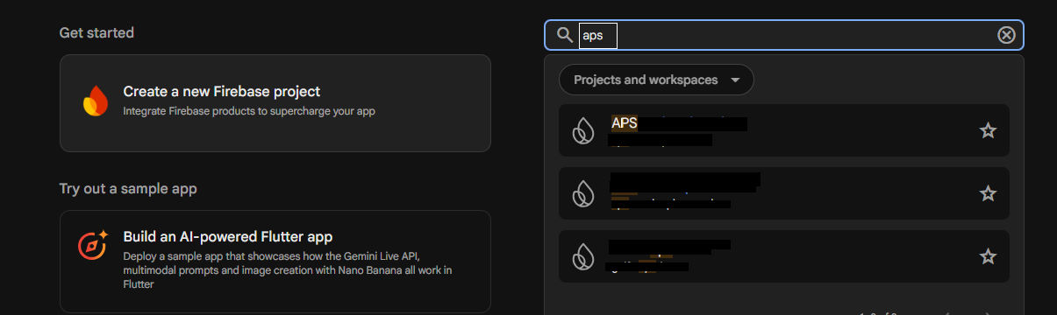
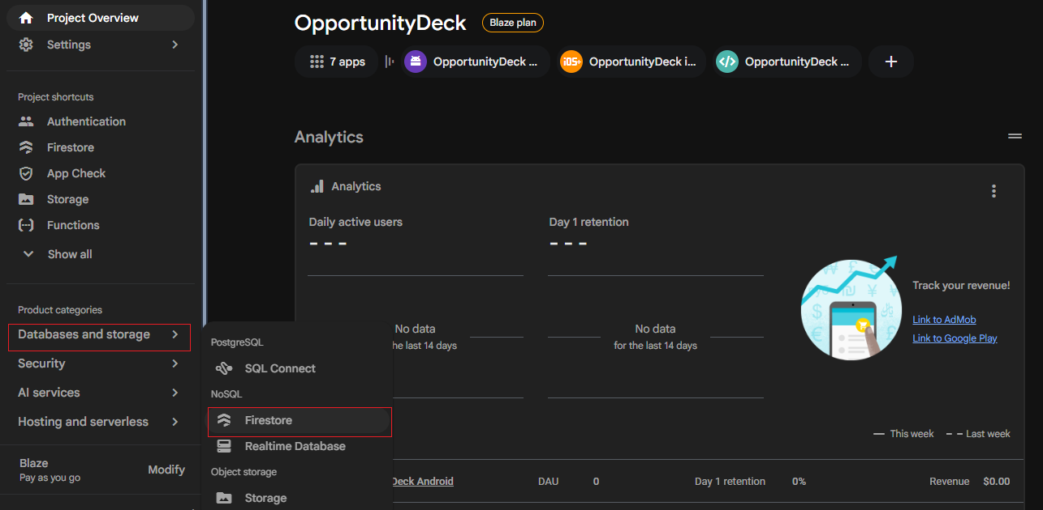

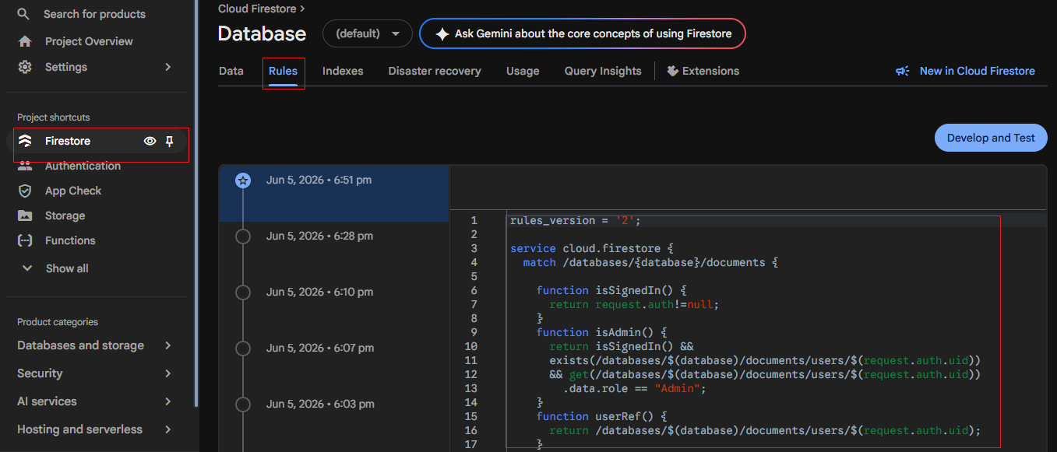

Helper Functions — Keeping Rules Clean
Rather than repeating the same condition across multiple rules, you define it once as a function. This makes rules easier to read, test, and maintain.

// Define once at the top of your rules file
function isSignedIn() {
return request.auth != null;
}
function isVerified() {
return request.auth.token.email_verified == true;
}
function isOwner(ownerRef) {
return request.auth.uid ==
ownerRef.id;
}
function isParticipant(participants) {
return request.auth.uid in participants;
}
// Use them cleanly in rules
allow create: if isSignedIn() && isVerified();
allow update: if isOwner(resource.data.created_by);
allow read: if isParticipant(resource.data.participants);

Rule Evaluation: Allow-by-Default-Deny
Firestore Security Rules use a default-deny model. If no rule explicitly allows an operation, it is denied. Rules are not additive — if one rule allows and another denies, the allow wins only if the condition is satisfied. You do not need to write explicit deny rules; absence of an allow is itself a denial.

📌 Important: Rules are OR-evaluated
If you write multiple allow statements for the same operation, Firebase grants access if ANY of them evaluates to true. For example:
allow read: if isOwner(resource.data.created_by);
allow read: if isAdmin();
Both lines apply to read. A request passes if the user is either the owner OR an admin.

6. Practical Use Case: Posts, Chat, Reports & Blocks

We will now apply advanced rules to two real collections from a social app. The use case builds on the Posts collection from the introductory guide, and adds a Chat (one-to-one messages) collection, plus user Report and Block capabilities.

📌 Full App Scenario
Posts Collection:
• Only authenticated users with a verified email can create a post.
• Posts must have a non-empty title and body (field validation).
• All users (including guests) can read posts.
• Only the original author can edit their post — and cannot change created_by or created_at.
• Only the original author or an admin can delete a post.

Chat Messages Collection:
• Only participants listed in the chat document can read messages.
• Only participants can send (create) new messages.
• Messages cannot be edited once sent.
• Only the sender can delete their own message.

Reports Collection:
• Any authenticated user can report another user or post.
• Only admins can read all reports.
• Reports cannot be edited or deleted by anyone except admins.

Blocks Collection:
• Any authenticated user can block another user.
• A user can only read, create, or delete their own block records.
• Block records cannot be modified — only created or deleted.

Collection Schemas

posts
Field | Type | Notes
title | String | Required, non-empty
body | String | Required, non-empty
created_by | Document Reference (users) | Set at creation, immutable after
created_at | Timestamp | Set at creation, immutable after

messages (subcollection of chats/{chatId}/messages)
Field | Type | Notes
text | String | Required, non-empty
sent_by | String (user UID) | Set at creation, immutable
sent_at | Timestamp | Set at creation, immutable
participants | Array of UIDs (on parent chat doc) | Stored on chats/{chatId}, checked in message rules via get()

reports
Field | Type | Notes
reported_by | String (user UID) | The user filing the report
target_type | String (user / post) | What is being reported
target_id | String | UID or post ID of the reported entity
reason | String | Required, non-empty description

blocks
Field | Type | Notes
blocked_by | String (user UID) | The user who initiated the block
blocked_user | String (user UID) | The user being blocked
blocked_at | Timestamp | Set at creation, immutable

Writing the Advanced Rules Step by Step

Step 1 Set Up the Rules File Structure
Every Firebase rules file starts with the same boilerplate. Open Firebase Console → Firestore Database → Rules tab.

rules_version = '2';
service cloud.firestore {
match /databases/{database}/documents {
// All helper functions and collection rules go here
}
}

Step 2 Write Shared Helper Functions
Define reusable functions at the top of the match block. These will be called across all collection rules.

// Is the user authenticated at all?
function isSignedIn() {
return request.auth != null;
}
// Has the user verified their email?
function isVerified() {
return request.auth.token.email_verified == true;
}
// Does the logged-in user match a given user reference?
function isOwner(userRef) {
return request.auth.uid == userRef.id;
}
// Is the logged-in user an admin?
// We check their role field in the users collection.
function isAdmin() {
return get(/databases/$(database)/documents/users/$(request.auth.uid))
.data.role == 'admin';
}
// Is the user a participant in a given chat?
function isParticipant(chatId) {
return request.auth.uid in
get(/databases/$(database)/documents/chats/$(chatId)).data.participants;
}

💡 Why Helper Functions Matter
Without helper functions, the isAdmin() check would need to be copy-pasted into every rule that references it. If your users collection path ever changes, you would need to update it in a dozen places. Functions make rules maintainable.

Step 3 Posts Collection Rules
Now write the rules for the posts collection, calling the helper functions we defined above.

match /posts/{postId} {
// CREATE: Must be signed in, email verified, and post must have content
allow create: if isSignedIn()
&& isVerified()
&& request.resource.data.title.size() > 0
&& request.resource.data.body.size() > 0
&& request.resource.data.created_by ==
/databases/$(database)/documents/users/$(request.auth.uid);
// READ: Everyone can read posts (public feed)
allow read: if true;
// UPDATE: Only the original author can edit.
// They cannot change created_by or created_at (immutable fields).
allow update: if isSignedIn()
&& isOwner(resource.data.created_by)
&& request.resource.data.created_by == resource.data.created_by
&& request.resource.data.created_at == resource.data.created_at
&& request.resource.data.title.size() > 0
&& request.resource.data.body.size() > 0;
// DELETE: The author can delete their own post, OR an admin can.
allow delete: if isSignedIn()
&& (isOwner(resource.data.created_by) || isAdmin());
}

Breaking Down the Posts Rules

- Create — email verification: We check request.auth.token.email_verified to ensure the user has confirmed their email. This blocks users who registered but never verified.
- Create — field validation: title.size() > 0 and body.size() > 0 check that these fields exist and are not empty strings. This cannot be done in the FlutterFlow UI rules at all.
- Create — self-attribution: We verify the created_by field in the incoming document matches the current user's path. This prevents one user from creating a post attributed to someone else.
- Update — immutable fields: By checking that created_by and created_at in the incoming data match the existing data, we prevent the author from reassigning a post or changing its timestamp.
- Delete — admin override: Admins can delete any post regardless of authorship. This enables moderation. The isAdmin() function does a cross-collection lookup to verify the role field.
Step 4 Chat Messages Rules
The chat use case requires array-based participant checking — something impossible in the FlutterFlow UI. Each chat document has a participants array of user UIDs. Messages live in a subcollection.

match /chats/{chatId} {
// Only participants can read the chat document itself
allow read: if isSignedIn()
&& isParticipant(chatId);
// Only authenticated users can create a new chat
allow create: if isSignedIn()
&& request.auth.uid in request.resource.data.participants;
// Participants can update the chat (e.g. last message preview)
allow update: if isSignedIn() && isParticipant(chatId);
// No one can delete a chat via the client
allow delete: if false;
match /messages/{messageId} {
// Only chat participants can read messages
allow read: if isSignedIn() && isParticipant(chatId);
// Only a participant can send a message,
// and sent_by must equal their own UID
allow create: if isSignedIn()
&& isParticipant(chatId)
&& request.resource.data.sent_by == request.auth.uid
&& request.resource.data.text.size() > 0;
// Messages cannot be edited once sent
allow update: if false;
// Only the sender can delete their own message
allow delete: if isSignedIn()
&& resource.data.sent_by == request.auth.uid;
}
}

Breaking Down the Chat Rules

- Participant check via get(): The isParticipant() function reads the parent chats/{chatId} document to check whether the current user's UID is in the participants array. This is a cross-document lookup — unavailable in FlutterFlow's UI.
- No message editing: update: if false means messages are immutable once sent, preserving chat integrity and preventing history tampering.
- Self-attribution enforcement: sent_by must equal the current user's UID at creation time, preventing one user from sending messages appearing to come from another.
- Subcollection inheritance: The match /messages/{messageId} block is nested inside match /chats/{chatId}, giving it access to the chatId variable for the participant lookup.
Step 5 Reports Collection Rules
Any signed-in user can file a report. Only admins can read the reports list. Nobody can edit a report — only create or (admin-only) delete.

match /reports/{reportId} {
// CREATE: Any authenticated user can submit a report.
// reported_by must match the submitting user.
// reason must be non-empty.
allow create: if isSignedIn()
&& request.resource.data.reported_by == request.auth.uid
&& request.resource.data.reason.size() > 0;
// READ: Only admins can see the reports list.
allow read: if isSignedIn() && isAdmin();
// UPDATE: Nobody can edit a report once submitted.
allow update: if false;
// DELETE: Only admins can remove a report.
allow delete: if isSignedIn() && isAdmin();
}

🛡️ Why reported_by Must Match the Current User
Without this check, a malicious user could submit a report with reported_by set to someone else's UID — framing another user as the reporter. By enforcing reported_by == request.auth.uid at the rule level, the attribution is guaranteed regardless of what data the client sends.

Step 6 Blocks Collection Rules
A user can block another user. They can only see, create, and remove their own block records. No one can edit a block — only create or delete it.

match /blocks/{blockId} {
// CREATE: Only the user creating the block can do so,
// and blocked_by must match their own UID.
allow create: if isSignedIn()
&& request.resource.data.blocked_by == request.auth.uid;
// READ: Users can only see their own block records.
allow read: if isSignedIn()
&& resource.data.blocked_by == request.auth.uid;
// UPDATE: Block records are immutable — to change a block,
// delete and recreate it.
allow update: if false;
// DELETE: Only the user who created the block can remove it.
allow delete: if isSignedIn()
&& resource.data.blocked_by == request.auth.uid;
}

Step 7 The Complete Rules File
Here is the full, production-ready rules file combining all collections from this guide.

rules_version = '2';
service cloud.firestore {
match /databases/{database}/documents {
// ── Helper Functions ─────────────────────────────────
function isSignedIn() {
return request.auth != null;
}
function isVerified() {
return request.auth.token.email_verified == true;
}
function isOwner(userRef) {
return request.auth.uid == userRef.id;
}
function isAdmin() {
return get(/databases/$(database)/documents/users/$(request.auth.uid))
.data.role == 'admin';
}
function isParticipant(chatId) {
return request.auth.uid in
get(/databases/$(database)/documents/chats/$(chatId)).data.participants;
}
// ── posts ─────────────────────────────────────────────
match /posts/{postId} {
allow create: if isSignedIn() && isVerified()
&& request.resource.data.title.size() > 0
&& request.resource.data.body.size() > 0
&& request.resource.data.created_by ==
/databases/$(database)/documents/users/$(request.auth.uid);
allow read: if true;
allow update: if isSignedIn() && isOwner(resource.data.created_by)
&& request.resource.data.created_by == resource.data.created_by
&& request.resource.data.created_at == resource.data.created_at
&& request.resource.data.title.size() > 0
&& request.resource.data.body.size() > 0;
allow delete: if isSignedIn()
&& (isOwner(resource.data.created_by) || isAdmin());
}
// ── chats + messages ──────────────────────────────────
match /chats/{chatId} {
allow read: if isSignedIn() && isParticipant(chatId);
allow create: if isSignedIn()
&& request.auth.uid in request.resource.data.participants;
allow update: if isSignedIn() && isParticipant(chatId);
allow delete: if false;
match /messages/{messageId} {
allow read: if isSignedIn() && isParticipant(chatId);
allow create: if isSignedIn() && isParticipant(chatId)
&& request.resource.data.sent_by == request.auth.uid
&& request.resource.data.text.size() > 0;
allow update: if false;
allow delete: if isSignedIn()
&& resource.data.sent_by == request.auth.uid;
}
}
// ── reports ───────────────────────────────────────────
match /reports/{reportId} {
allow create: if isSignedIn()
&& request.resource.data.reported_by == request.auth.uid
&& request.resource.data.reason.size() > 0;
allow read: if isSignedIn() && isAdmin();
allow update: if false;
allow delete: if isSignedIn() && isAdmin();
}
// ── blocks ────────────────────────────────────────────
match /blocks/{blockId} {
allow create: if isSignedIn()
&& request.resource.data.blocked_by == request.auth.uid;
allow read: if isSignedIn()
&& resource.data.blocked_by == request.auth.uid;
allow update: if false;
allow delete: if isSignedIn()
&& resource.data.blocked_by == request.auth.uid;
}
}
}

7. Quick Reference Summary

Collection | Operation | Rule Applied
posts | Create | Authenticated + verified email + field validation + self-attribution
posts | Read | Everyone (public feed)
posts | Update | Owner only + immutable field protection + field validation
posts | Delete | Owner OR Admin (cross-collection role check)
chats | Read / Update | Participant only (array-contains check via get())
chats/messages | Read / Create | Participant only — create also validates sent_by and non-empty text
chats/messages | Update | Nobody — messages are immutable once sent
chats/messages | Delete | Sender only
reports | Create | Authenticated + self-attributed + non-empty reason
reports | Read / Delete | Admin only (cross-collection role check)
blocks | Create | Authenticated + blocked_by must equal own UID
blocks | Read / Delete | Owner of the block record only
blocks | Update | Nobody — delete and recreate to change a block

8. Rule Keywords Glossary

Every keyword used in Firestore Security Rules has a specific scope and purpose. Some operate on a single document or single user — others are designed to work across lists, arrays, or multiple collections. The table below summarises every keyword used in this guide, what it targets, whether it handles a single value or a list, and where in the guide you can see it applied.

📖 How to Read This Table
Single — the keyword checks or matches one value at a time (e.g. one user UID, one field, one document).
List / Collection — the keyword operates on multiple values, an array of items, or a set of documents.
The 'Used In This Guide' column links to the section where the keyword is applied in a real rule.

Request & Resource Objects
These are the two built-in objects available inside every rule condition. They describe the incoming operation and the existing state of the database.

Keyword | Single / List | What It Is | Used In This Guide
request.auth | Single | The authenticated user making the request. Null if unauthenticated. | All collections — isSignedIn(), isOwner(), isAdmin()
request.auth.uid | Single | The unique ID string of the currently signed-in user. | posts (self-attribution), reports (reported_by), blocks (blocked_by)
request.auth.token.email_verified | Single | Boolean — true if the user has verified their email address. | posts → Create rule (Section 6, Step 3)
request.resource.data | Single (doc) | The incoming document data being written. Does not exist in Firestore yet. | posts → Create & Update (field validation, self-attribution)
resource.data | Single (doc) | The existing document already stored in Firestore before this operation. | posts → Update & Delete (checking created_by, created_at)
request.time | Single | The server timestamp at the moment the request is evaluated. | Not used in this guide — useful for rate limiting and time-gated access.

Match & Path Keywords
These keywords define which documents a rule block applies to. They are the structural skeleton of every rules file.

Keyword | Single / List | What It Is | Used In This Guide
match /collection/{id} | Single doc | Matches one specific document in a collection. The {id} wildcard captures the document ID. | All four collections — posts/{postId}, chats/{chatId}, etc.
match /a/{b}/sub/{c} | Single doc | Matches a document inside a subcollection. Both the parent and child IDs are captured as variables. | chats/{chatId}/messages/{messageId} (Section 6, Step 4)
match /{path=**} | List / All | Recursive wildcard — matches all documents at every depth under the current path. Used as a catch-all fallback. | Not used in this guide — best applied as a final deny-all rule in production.

Allow Operations
These keywords declare which Firestore operations a rule block controls. Each one maps directly to a database action.

Keyword | Single / List | What It Controls | Used In This Guide
allow create | Single doc | Adding a new document that does not yet exist in the collection. | posts, chats, messages, reports, blocks (Section 6)
allow read | Single + List | Covers both get (fetch one doc) and list (query multiple docs). Applies to individual reads and collection queries. | All collections — public posts, participant-only chat, admin-only reports
allow update | Single doc | Modifying fields of an existing document. Does not cover creation or deletion. | posts (owner + immutable fields), chats (participants), messages (false — immutable)
allow delete | Single doc | Permanently removing a document from a collection. | posts (owner or admin), messages (sender only), reports & blocks (owner / admin)
allow write | Single doc | Shorthand covering create + update + delete in one rule. Use when the same condition applies to all three. | Not used individually in this guide — each operation is declared separately for precision.
allow read, write: if false | Single doc | Explicitly denies an operation for everyone. No one, including admins, can perform it via the client. | messages → update (immutable), chats → delete, blocks → update (Section 6)

Cross-Collection Lookup Functions
These built-in functions allow a rule to read data from other parts of the database during evaluation. They are what make truly advanced access control possible.

Keyword | Single / List | What It Does | Used In This Guide
get(/path/$(var)) | Single doc | Reads one specific document from Firestore during rule evaluation. Returns the full document so you can access .data fields. | isAdmin() — reads user's role field. isParticipant() — reads chat's participants array. (Section 6, Steps 2–4)
exists(/path/$(var)) | Single doc | Checks whether a document exists at a given path without reading its contents. Cheaper than get() when you only need a yes/no answer. | Not used in this guide — useful for subscription or membership checks without reading full documents.

List & Array Operators
These operators are specifically designed for rules that involve multiple users or values — such as checking whether a user is in a participants list. This is where advanced rules go beyond anything the FlutterFlow UI can express.

Keyword | Single / List | What It Does | Used In This Guide
value in list | List | Returns true if the value exists anywhere in the array. The core operator for multi-user and multi-participant rules. | isParticipant() — checks request.auth.uid in participants array (Section 6, Step 4)
list.size() | List | Returns the number of items in an array or the number of characters in a string. Used for non-empty field validation. | posts → title.size() > 0, body.size() > 0. messages → text.size() > 0. reports → reason.size() > 0. (Section 6, Steps 3–6)
list.hasAll() | List | Returns true if the array contains every item in the provided list. Useful for checking multiple required roles or tags. | Not used in this guide — useful for multi-role or multi-tag access scenarios.
list.hasAny() | List | Returns true if the array contains at least one item from the provided list. | Not used in this guide — useful when a user onlyneeds to match one of several allowed roles.

Logical & Comparison Operators
These operators combine and compare conditions inside rule expressions. They are the glue that connects multiple checks into a single allow statement.

Keyword | Single / List | What It Does | Used In This Guide
&& | Both | Logical AND — all connected conditions must be true for the rule to allow the operation. | Every multi-condition rule — e.g. isSignedIn() && isVerified() && field validation (Section 6, Step 3)
|| | Both | Logical OR — at least one of the conditions must be true. | posts → Delete: isOwner() || isAdmin() — either the author or an admin may delete. (Section 6, Step 3)
== | Single | Equality check — both sides must be identical. Used to match UIDs, references, and field values. | Immutable field checks (created_by, created_at), self-attribution (blocked_by, reported_by) throughout Section 6
!= | Single | Inequality check — the two values must differ. | Not used in this guide — useful for preventing a user from performing an action on themselves (e.g. blocking themselves).
! | Single | Logical NOT — inverts a boolean condition. | Not used in this guide — commonly used as !isSignedIn() to target guest users.

Further Reading & Official References
The table above covers the keywords used throughout this guide. For the full Firebase Security Rules language reference, the resources below are the authoritative sources.

Topic | Link
Firebase Security Rules — Full Language Reference | https://firebase.google.com/docs/rules/rules-language
Firestore Security Rules — Get Started Guide | https://firebase.google.com/docs/firestore/security/get-started
Security Rules — Writing Conditions | https://firebase.google.com/docs/rules/rules-and-auth
Cross-Document Reads in Rules (get / exists) | https://firebase.google.com/docs/firestore/security/rules-conditions#access_other_documents
Firestore Data Types in Rules | https://firebase.google.com/docs/rules/data-types
Rules Simulator — Test Without Deploying | https://firebase.google.com/docs/firestore/security/test-rules-emulator
FlutterFlow — Firestore Rules Documentation | https://docs.flutterflow.io/integrations/database/cloud-firestore/firestore-rules
Introductory Guide — Security Rules Implementation using FlutterFlow | https://docs.google.com/document/d/1V-YN96lmiDvrbAlaeEZJSjIea2j-bS2o/edit?usp=sharing&ouid=110499363608826219416&rtpof=true&sd=true

Advanced Security Rules Guide · FlutterFlow & Firebase · For the introductory guide, see: Security Rules Implementation using FlutterFlow

